DESIGN DOCUMENTATION
Project Name: Build Track - Real Estate
1. SYSTEM DESIGN
1.1 Architectural Overview
The 'Build Track - Real Estate House Building Inventory and Progress Tracker' (Build Track - Real Estate) is an automated web platform designed to streamline real estate construction. It tracks raw building materials, eliminates on-site wastage and theft, and records physical milestone completion for residential houses. The system uses a clean 3-tier structure: (1) a user-friendly Bootstrap 5 web interface for desktop and mobile phones, (2) a Python Flask backend that manages user permissions, stage progress calculations, and inventory deduction rules, and (3) a high-reliability MySQL 8.0 database that guarantees data consistency and stores a permanent audit trail.
1.2 Data Flow Diagrams (DFD)
Data Flow Diagrams show how construction information moves between real-world people (Administrators, Site Engineers, Suppliers) and the automated database.
1.2.1 DFD Level 0: Context Level Diagram (System Boundary)
The Level 0 Context Diagram shows the system as a single central engine interacting with its three external stakeholders. The Administrator sets up projects and receives financial summaries; the Builder/Site Engineer submits daily material usage and stage progress; and the Material Supplier receives purchase orders and sends delivery invoices.
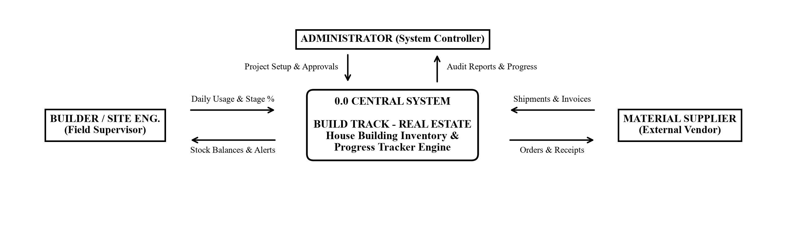
1.2.2 DFD Level 1: Subsystems Decomposition Diagram
The Level 1 Diagram breaks down the central system into five core functional modules: User Login (1.0), House Projects (2.0), Materials Catalog (3.0), Daily Stock Movement (4.0), and Verification Queue (5.0). These modules securely read and write information to four central data stores (D1 through D4).
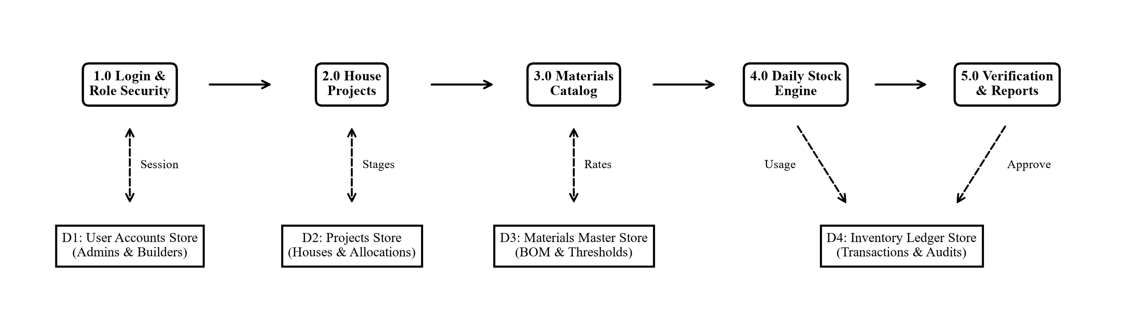

1.2.3 DFD Level 2: Detailed Transaction Processing Flow (Stock Usage & Approvals)
The Level 2 flowchart explains the exact step-by-step logic when a site engineer logs material usage from a construction site:
1. Input: The site engineer enters the House ID, Material, and Quantity consumed on-site.
2. Stock Check: The system queries the database to verify if enough stock is physically available.
3. Decision: If stock is insufficient, an immediate low-stock alert is shown and the entry is rejected. If valid, the stock is temporarily held and queued with 'PENDING' status.
4. Approval & Commit: The Administrator reviews the entry and approves it, permanently recording it in the audit ledger.
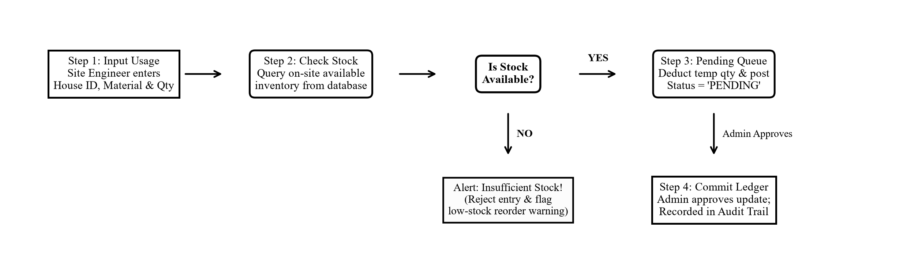
1.3 Unified Modeling Language (UML) Diagrams
UML diagrams specify the system's human user interactions and object-oriented software components.
1.3.1 UML Use Case Diagram (All User Roles & System Features)
The Use Case diagram clearly divides responsibilities between the Administrator (left) and the Site Engineer (right):
* Administrator Features: Login security (UC-01), maintaining master materials & prices (UC-02), assigning plots to builders (UC-03), reviewing construction milestones (UC-04), and authorizing material usage with cost reports (UC-05).
* Site Engineer Features: Viewing assigned house projects (UC-06), updating stage completion percentage (UC-07), logging daily cement/steel usage (UC-08), recording inward truck deliveries (UC-09), and running civil material estimates (UC-10).
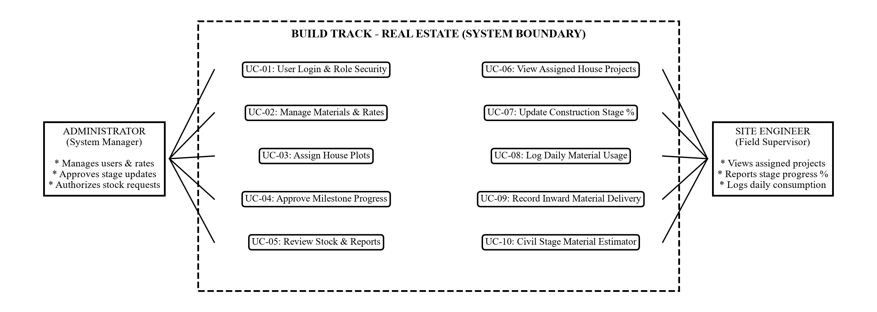

1.3.2 UML Class Diagram (Domain Model & Operations)
The Class Diagram shows the six core software objects in the platform, including their data attributes and callable functions:
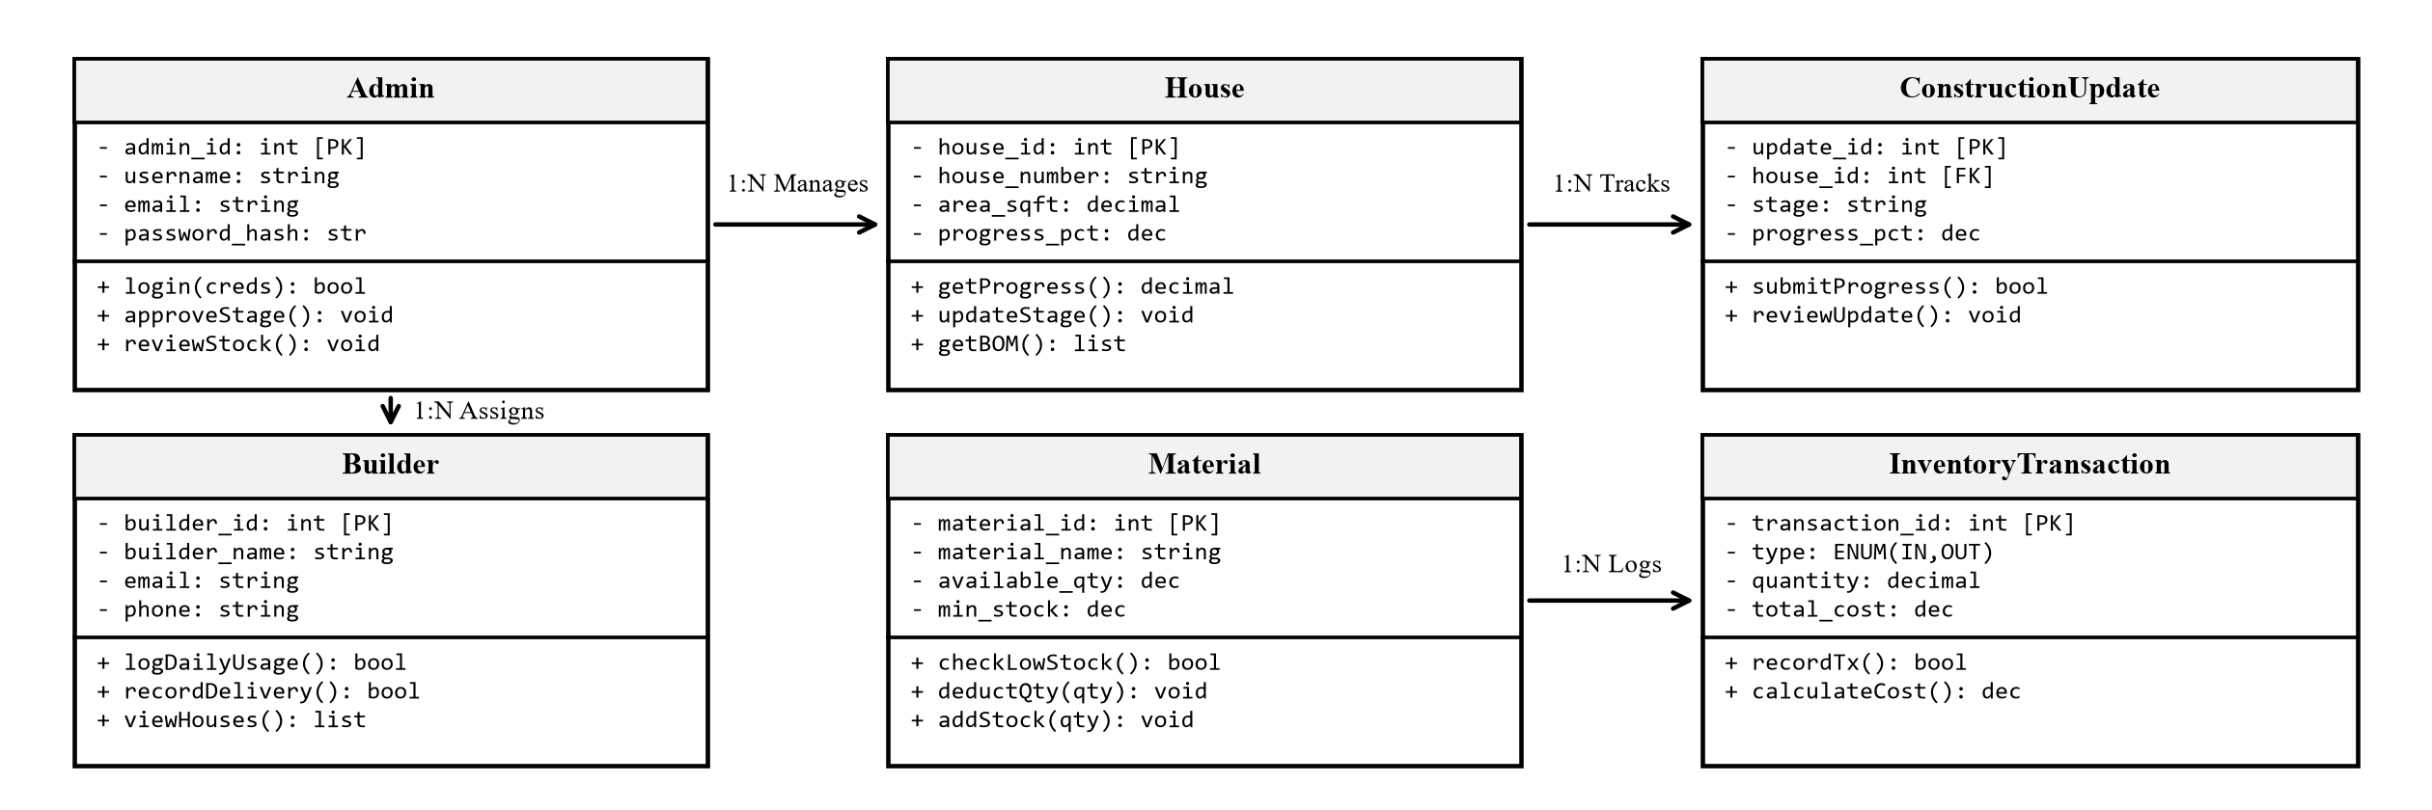
Relationships: One Admin manages multiple Houses (1:N) and assigns them to Builders (1:N). Each House records multiple Construction Updates (1:N) as it progresses from Foundation to Finishing. Daily stock usage and delivery receipts are permanently stored as Inventory Transactions (1:N) linked to both Houses and Materials.
2. DATABASE DESIGN
2.1 MySQL Relational Entity-Relationship (ER) Diagram
The database is normalized to Third Normal Form (3NF) to eliminate duplicate data, protect financial accuracy, and maintain strong relational integrity across all project tables:
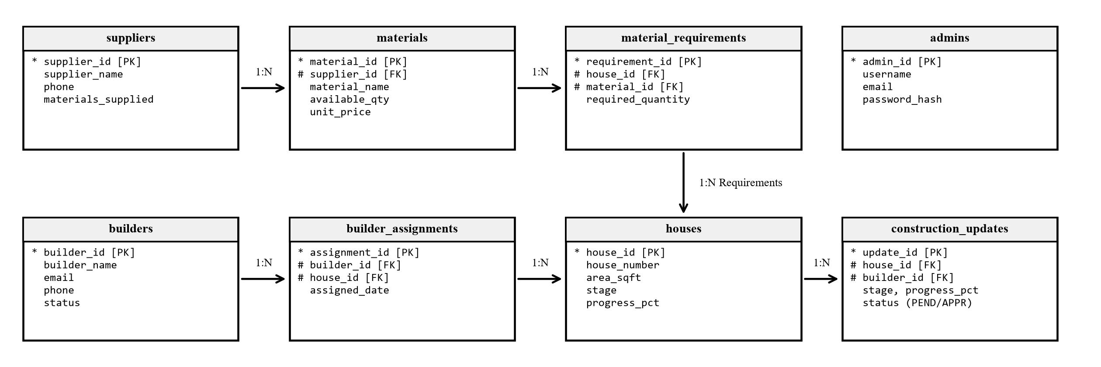
Key Connections: Suppliers connect to Materials (1:N), which link to Bill of Materials (BOM) Requirements for each House. Builders are allocated to Houses through assignments, and their submitted field entries flow directly into approval queues for admin verification.

2.2 Structured Data Dictionary (Core Relational Tables)
The Data Dictionary defines the exact structure, data types, keys, and practical business purpose of every table in the MySQL database:
Table 1: admins (System Administrators & Managers)
Column Name | Data Type | Keys / Null | Description & Practical Purpose
admin_id | INT | PK, NOT NULL | Unique administrative ID (Auto Increment).
username | VARCHAR(50) | UNIQUE, NOT NULL | Login handle used to access the web portal.
full_name | VARCHAR(100) | NOT NULL | Official name of the project administrator.
email | VARCHAR(100) | UNIQUE, NOT NULL | Official email for system alerts and recovery.
password_hash | VARCHAR(255) | NOT NULL | Securely hashed password for authentication.
created_at | DATETIME | NOT NULL | Timestamp when the admin account was created.

Table 2: builders (Field Supervisors & Site Engineers)
Column Name | Data Type | Keys / Null | Description & Practical Purpose
builder_id | INT | PK, NOT NULL | Unique engineer identifier (Auto Increment).
builder_name | VARCHAR(100) | NOT NULL | Full legal name of the site engineer.
email | VARCHAR(100) | UNIQUE, NOT NULL | Email used to log in from field mobile devices.
phone | VARCHAR(20) | NOT NULL | Active phone number for urgent site alerts.
password_hash | VARCHAR(255) | NOT NULL | Secure encrypted password hash.
status | ENUM('Active','Inactive') | NOT NULL | Account status (Default is 'Active').

Table 3: houses (Residential Housing Plots & Units)
Column Name | Data Type | Keys / Null | Description & Practical Purpose
house_id | INT | PK, NOT NULL | Unique house project identifier (Auto Increment).
house_number | VARCHAR(50) | UNIQUE, NOT NULL | Plot or Villa code (e.g., 'VIL-101', 'BLK-A4').
house_type | VARCHAR(50) | NOT NULL | Architectural model (e.g., 'Luxury Villa', 'Row House').
bhk | VARCHAR(20) | NOT NULL | Room specification (e.g., '3 BHK', '4 BHK Duplex').
area_sqft | DECIMAL(10,2) | NOT NULL | Total built-up construction area in square feet.
location | VARCHAR(150) | NOT NULL | Physical site sector, road, or layout zone.
construction_stage | ENUM(9 stages) | NOT NULL | Current structural phase (Default: 'Foundation').
progress_pct | DECIMAL(5,2) | NOT NULL | Overall milestone completion percentage (0.00 to 100.00%).
status | ENUM(4 states) | NOT NULL | State: Planned, Under Construction, On Hold, Completed.

Table 4: builder_house_assignments (Engineer Project Allocations)
Column Name | Data Type | Keys / Null | Description & Practical Purpose
assignment_id | INT | PK, NOT NULL | Unique project allocation record identifier.
builder_id | INT | FK, NOT NULL | Assigned site engineer (References builders.builder_id).
house_id | INT | FK, NOT NULL | Allocated house project (References houses.house_id).
assigned_date | DATETIME | NOT NULL | Date and time when supervisor was assigned to plot.
status | ENUM(3 states) | NOT NULL | Assignment state: 'Active', 'Reassigned', or 'Completed'.

Table 5: suppliers (Material Vendors & Wholesale Suppliers)
Column Name | Data Type | Keys / Null | Description & Practical Purpose
supplier_id | INT | PK, NOT NULL | Unique material supplier identifier (Auto Increment).
supplier_name | VARCHAR(150) | NOT NULL | Registered corporate name of the material vendor.
contact_person | VARCHAR(100) | NOT NULL | Name of vendor sales representative or manager.
phone | VARCHAR(20) | NOT NULL | Direct contact number for placing purchase orders.
materials_supplied | TEXT | NULL | List of supplies provided (e.g., Cement, TMT Steel, Sand).

Table 6: materials (Master Inventory Catalog & Standard Prices)
Column Name | Data Type | Keys / Null | Description & Practical Purpose
material_id | INT | PK, NOT NULL | Unique master material ID (Auto Increment).
material_name | VARCHAR(150) | NOT NULL | Standard item name (e.g., 'OPC 53 Cement', '12mm Steel').
category | VARCHAR(100) | NOT NULL | Classification (Cement, Steel, Bricks, Aggregates, Paint).
unit | VARCHAR(50) | NOT NULL | Standard unit of measurement (Bags, Tons, CFT, Liters).
available_quantity | DECIMAL(12,2) | NOT NULL | Current physical inventory available on the construction site.
minimum_stock_level | DECIMAL(12,2) | NOT NULL | Safety buffer quantity; triggers reorder alert when reached.
unit_price | DECIMAL(10,2) | NOT NULL | Standard procurement price per unit in local currency.
supplier_id | INT | FK, NULL | Preferred vendor for this item (References suppliers.supplier_id).

Table 7: material_requirements (Bill of Materials Estimation per House)
Column Name | Data Type | Keys / Null | Description & Practical Purpose
requirement_id | INT | PK, NOT NULL | Unique BOM requirement record identifier.
house_id | INT | FK, NOT NULL | Target house receiving the materials (References houses.house_id).
material_id | INT | FK, NOT NULL | Required material item (References materials.material_id).
required_quantity | DECIMAL(12,2) | NOT NULL | Total estimated quantity needed to complete the house.
uk_house_material | UNIQUE KEY | NOT NULL | Prevents duplicate material rows for the same house project.

Table 8: inventory_transactions (IN / OUT Stock Movement History)
Column Name | Data Type | Keys / Null | Description & Practical Purpose
transaction_id | INT | PK, NOT NULL | Unique transaction record identifier (Auto Increment).
transaction_type | ENUM('IN','OUT') | NOT NULL | 'IN' for supplier delivery; 'OUT' for daily site usage.
material_id | INT | FK, NOT NULL | Material being moved (References materials.material_id).
house_id | INT | FK, NULL | Specific house plot receiving or consuming the material.
builder_id | INT | FK, NULL | Site engineer logging the stock movement.
quantity | DECIMAL(12,2) | NOT NULL | Numerical amount transferred (must be greater than 0.00).
unit_price | DECIMAL(10,2) | NOT NULL | Cost per unit applied to calculate expenditure.
total_cost | DECIMAL(12,2) | NOT NULL | Total monetary value of movement (Quantity * Unit Price).
transaction_date | DATE | NOT NULL | Physical date when the delivery or usage occurred.
status | ENUM('COMPLETED','CANCELLED') | NOT NULL | Transaction validity (Default: 'COMPLETED').

Table 9: construction_updates (Milestone Progress Submissions)
Column Name | Data Type | Keys / Null | Description & Practical Purpose
update_id | INT | PK, NOT NULL | Unique milestone submission identifier.
house_id | INT | FK, NOT NULL | House being updated (References houses.house_id).
builder_id | INT | FK, NOT NULL | Field supervisor reporting the work (References builders).
stage | VARCHAR(50) | NOT NULL | Completed civil stage (e.g., 'Brickwork', 'Roof Slab').
progress_pct | DECIMAL(5,2) | NOT NULL | Cumulative progress percentage achieved on this house.
status | ENUM('PENDING','APPROVED','REJECTED') | NOT NULL | Current approval state (Default: 'PENDING').
reviewed_by | INT | FK, NULL | Administrator who verified the work (References admins).

Table 10: stock_updates (Daily Field Stock Consumption Audit)
Column Name | Data Type | Keys / Null | Description & Practical Purpose
stock_update_id | INT | PK, NOT NULL | Unique daily consumption verification identifier.
house_id | INT | FK, NOT NULL | House where materials were used (References houses).
builder_id | INT | FK, NOT NULL | Site engineer who used the materials (References builders).
material_id | INT | FK, NOT NULL | Material item consumed (References materials).
opening_stock | DECIMAL(12,2) | NOT NULL | Physical stock count available before the day's work.
material_used | DECIMAL(12,2) | NOT NULL | Amount consumed on the structural task today.
remaining_stock | DECIMAL(12,2) | NOT NULL | Reconciled closing balance (Opening Stock minus Used).
status | ENUM('PENDING','APPROVED','REJECTED') | NOT NULL | Audit verification state (Default: 'PENDING').
reviewed_by | INT | FK, NULL | Administrator who confirmed the consumption (References admins).

2.3 Database Safety, Indexing & Reliability Controls
To ensure that construction and financial records remain 100% accurate, the database enforces strict integrity controls. ACID transaction boundaries ensure that material deductions and ledger entries happen together or not at all, preventing inventory mismatches during power or network drops. B-Tree database indexes guarantee that mobile app searches return in milliseconds, while foreign key rules prevent accidental deletion of critical historical records.

